November is Diabetes Awareness Month!

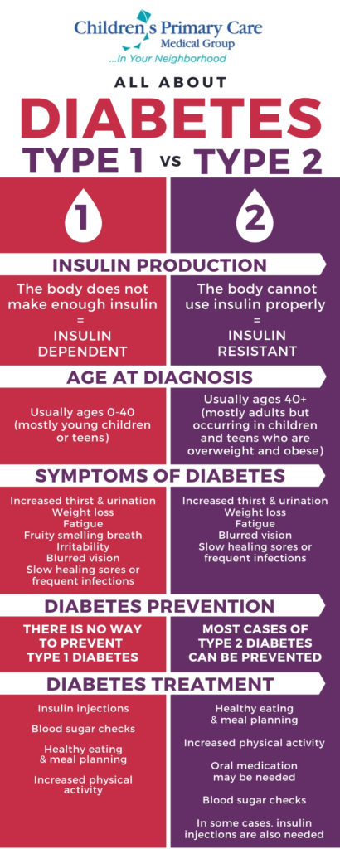
Please WEAR BLUE on Thursday Nov 12 in recognition of the world-wide fight against diabetes. Help raise the awareness of how Diabetes affects so many people! “Shine the Light” on diabetes by decorating with blue lights. The Blue Circle is the global symbol for diabetes. It signifies the unity of the global diabetes community in response to the rising number of people affected by diabetes. Take a creative picture using the blue circle app (Search: World Diabetes Day in your App store.) Post it to social media along with the 1-minute quiz to evaluate if you are at risk for developing Type 2 diabetes. http://www.diabetes.org/are-you-at-risk/diabetes-risk-test/

Do you know the difference between Type 1 and Type 2 diabetes?
Type 1 Diabetes is an autoimmune disease. The immune system mistakes the insulin-producing cells in the pancreas as “invaders” and attacks them. Once this happens, the cells can no longer produce insulin and the person must depend on insulin injections or an insulin pump to stay alive. Currently, there is no cure to for Type 1 diabetes.

Type 2 Diabetes is a metabolic condition. It’s when the body doesn’t produce enough insulin or becomes resistant to it. The condition can sometimes be controlled with proper diet and exercise, or a drug to enhance sensitivity to the body’s insulin production. More than 50% of Type 2 diabetes can be prevented!

Do you know the signs and symptoms of high and low blood sugars? Take a look at the link below. We have many students and teachers with Type 1 and Type 2 diabetes. Know how to support them!

https://diabetesed.net/page/_files/HyperHypo-handout.pdf

Let’s do our part in raising awareness of diabetes!

